OFFICE
For Sublease
Class A Office Space-5,534 SF

Oklahoma Tower

210 Park Avenue, Suite 1450
Oklahoma City, OK 73102
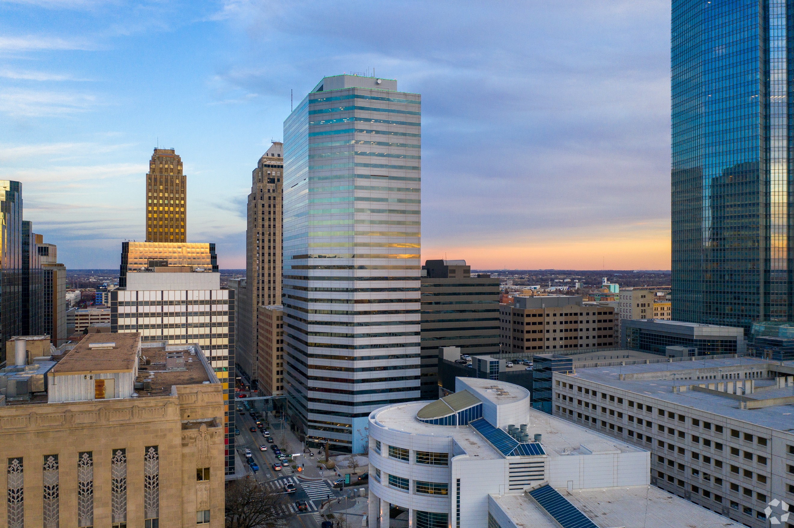

- 5,534 rsf
- Sublease Rate: $16.00/rsf (current asking rate for the property is $24.00)
- Sublease Term: Flexible through December 31, 2022 or December 31, 2024
- Tenant improvement allowance available
- Year built: 1982
- One of only a handful of Class A CBD buildings
- All weather access to restaurants and parking
- Office space in good condition with 7 private offices, 1 large conference room, reception, breakroom, file/mail room, 5 cubes
- On-site bank, men’s clothier and grill
- On-site security

P. SCOTT WIECZOREK

5030 N. May Avenue, #435, Oklahoma City, OK 73112 405.698.1150 (oﬃce) • 405.210.3894 (mobile)

scott@avenuecre.com • www.avenuecre.com

OFFICE For Sublease

